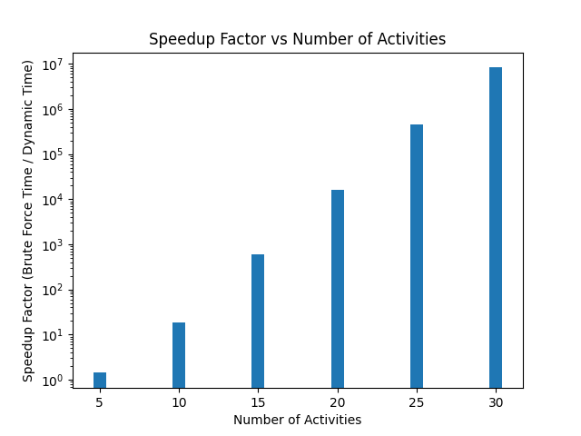
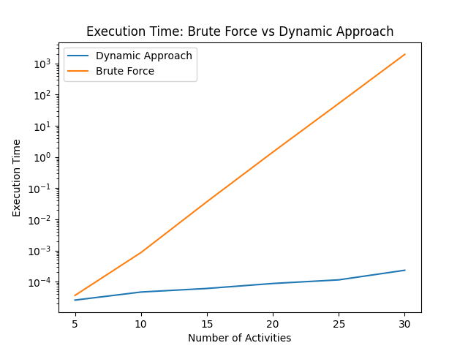
Performance Analysis

At what value of n does brute force become impractical (e.g., taking more than 10 minutes)?
In the line graph, we observe a highly linear relationship between execution time and number of activities (n).
Therefore, we can calculate the rate that execution time increases, as n (the number of activities in the list) increases, using the formula:
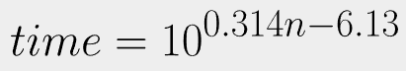
This will allow us to extrapolate the data and allow us to find the hypothetical execution time for any value of n.
Calculation: Finding n where time > 10 minutes
- 10 minutes = 600,000 ms
- log(600,000) = (0.314)n – 6.13
- (5.778 + 6.13) / 0.314 = n
- = 37.92…

Hence, brute force begins to be impractical at around 38 activities, as at this value of n, the program would take greater than 10 minutes to execute.

How does the dynamic programming execution time grow as n increases?
By observing the shape of the line graph (linear) we can derive a formula for the relationship between execution time and n for the dynamic approach program.


